

LAB EXPERIMENT RECORD
SET 22

Department | Artificial Intelligence and Data Science
Course Code / Course Name | DSA0601 / Data Handling and Visualization
Name / Register Number | ROHAN P T / 192424112
Date / Day | 15/10/2026

Aim
To analyze time series analysis using the requested visualizations and dashboard views.

Dataset
Time Series Analysis
Month | Sales | Advertising_Budget
January | 15000 | 5000
February | 18000 | 6000
March | 22000 | 7000
April | 20000 | 8000
May | 23000 | 9000

R Data Setup
Run this setup once before the R programs below. The dataset is defined inline so each record can be copied and run without a separate CSV file.
R data setup
dat <- data.frame(
Month = c("January", "February", "March", "April", "May"),
Sales = c(15000, 18000, 22000, 20000, 23000),
Advertising_Budget = c(5000, 6000, 7000, 8000, 9000)
)

PROGRAM 1: Monthly Sales Time Series
Create a labeled time-series line chart for monthly sales.
R code
plot(dat$Sales, type="o", xaxt="n", xlab="Month", ylab="Sales ($)", main="Monthly Sales Trend", col="#276B9A")
axis(1, at=seq_len(nrow(dat)), labels=dat$Month)

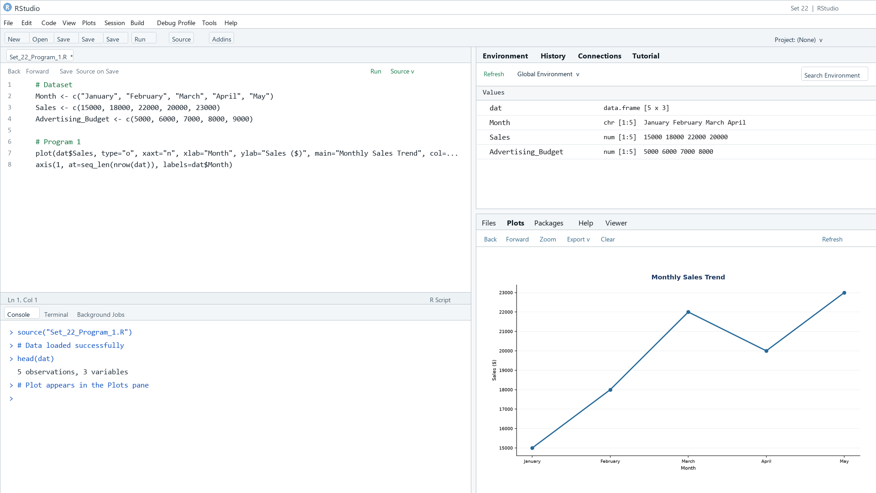
Output 1: Monthly Sales Time Series
Observation: Sales trend upward overall, with a small decline in April before reaching the highest value in May.

PROGRAM 2: Advertising Budget and Sales
Create a scatter plot of advertising budget versus monthly sales and describe the relationship.
R code
plot(dat$Advertising_Budget, dat$Sales, pch=19, col="#276B9A", xlab="Advertising budget ($)", ylab="Monthly sales ($)", main="Advertising Budget vs Monthly Sales")

.
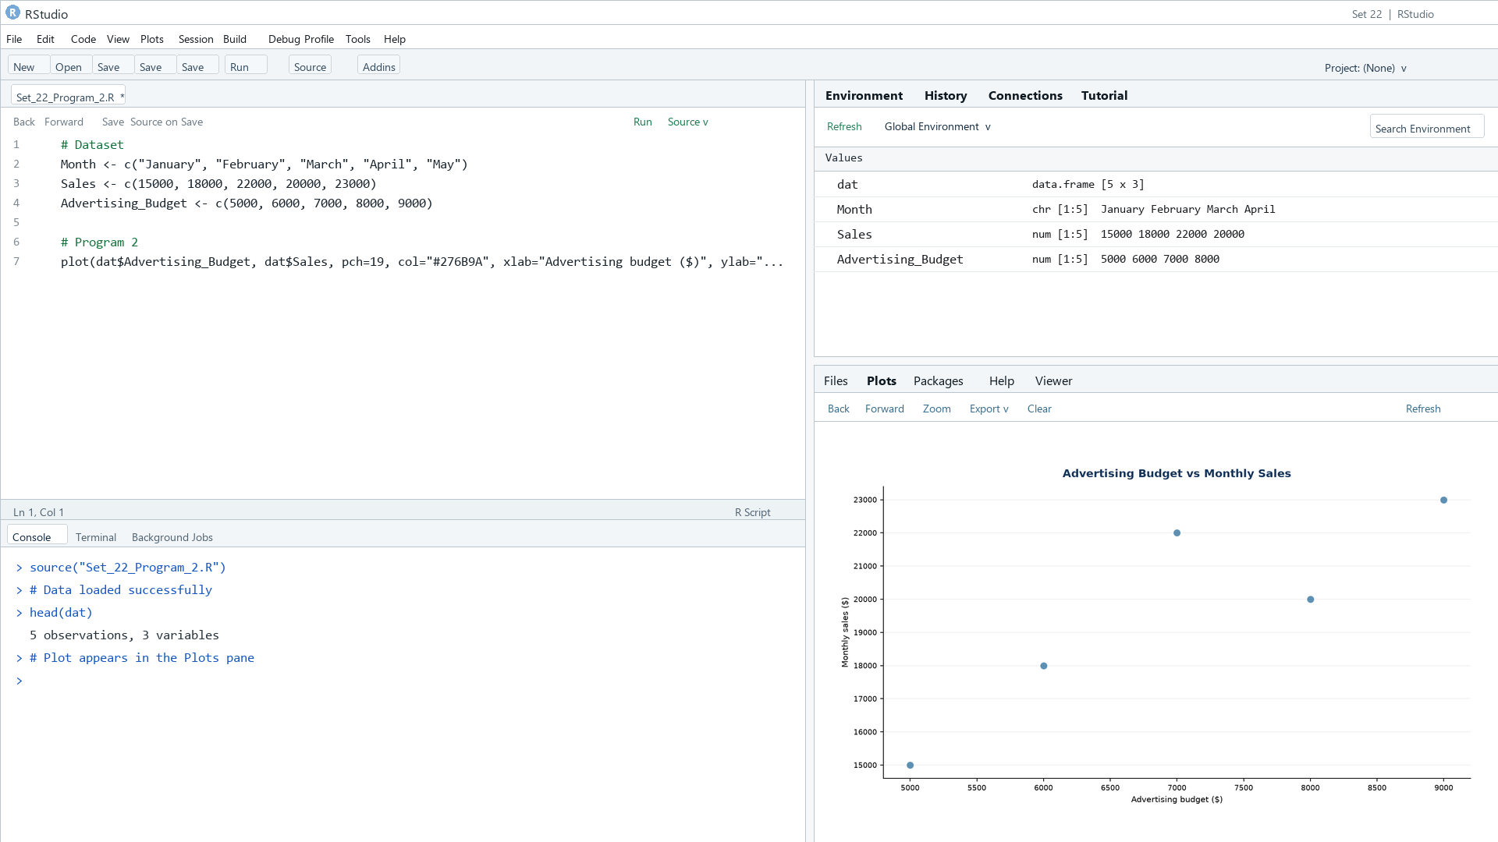
Output 2: Advertising Budget and Sales
Observation: The illustrative values show a positive association between advertising budget and sales; five points cannot establish a causal effect.

PROGRAM 3: Monthly Sales Dashboard
Build a Tableau dashboard with a sales trend line chart and a pie chart of product sales shares.
Tableau build steps
Tableau dashboard build
1. Connect to the monthly sales table.
2. Create a line chart of Sales by Month.
3. For the pie view, use a product-level sales source or replace the illustrative values with actual product totals.
4. Add both views to a dashboard.

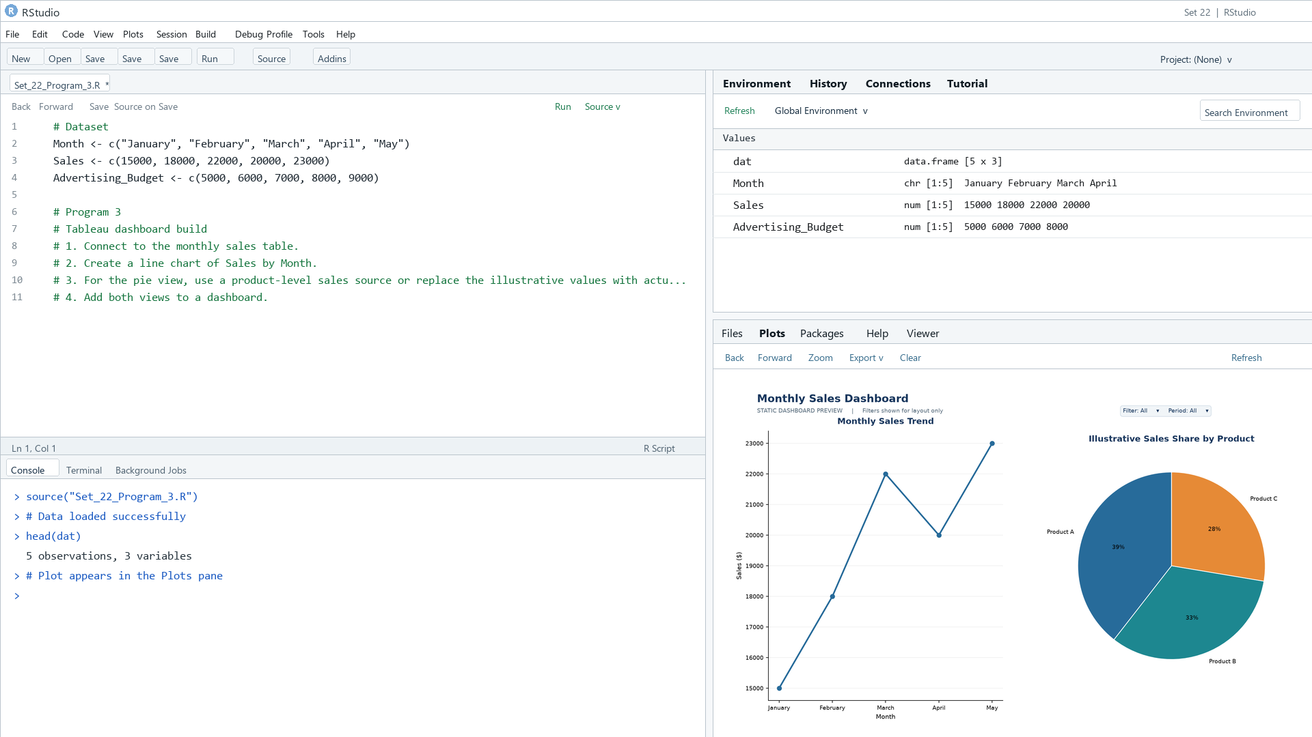
Output 3: Monthly Sales Dashboard
Observation: The preview shows the monthly series and an illustrative product-share pie. Product shares are not in the supplied monthly sales table.

PROGRAM 4: Monthly Sales Autocorrelation
Create an autocorrelation plot to inspect possible seasonality in monthly sales.
R code
sales_ts <- ts(dat$Sales, frequency=12)
acf(sales_ts, main="Autocorrelation of Monthly Sales")

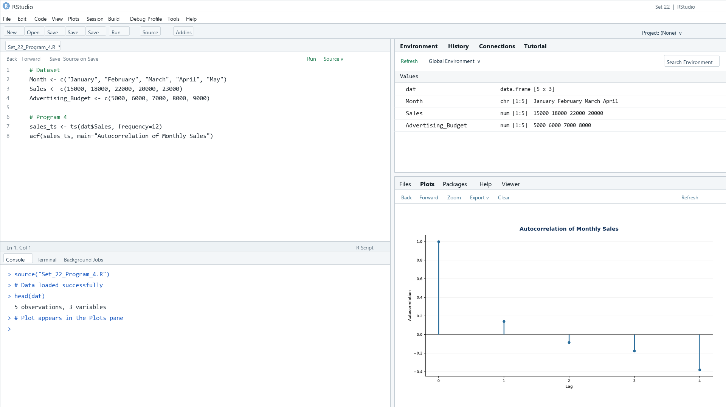
Output 4: Monthly Sales Autocorrelation
Observation: The five-point series is too short to establish seasonality; the autocorrelation view is only exploratory.

Procedure
1. Review the dataset table and confirm any illustrative fields noted in the record.
2. Run the R setup block once, then run the requested program code.
3. Compare the output screenshot with the observation and replace illustrative values when actual data is available.
4. For Tableau tasks, connect to the displayed data and follow the dashboard build steps.

Result
The requested charts and dashboard views for Set 22 were prepared from the displayed dataset. Outputs include labels, short observations, and code or dashboard construction steps.

Key Functions Used
plot(), barplot(), hist(), boxplot(), table().

